EASTERN INTERNATIONAL UNIVERSITY Practice Assignment – Quarter 1, 2024-2025
SCHOOL OF COMPUTING Course Name: OOD
AND INFORMATION TECHNOLOGY Course Code: CSE 203
Student’s Full Name:
Student ID:
Lab 6
- Shape Drawing Application (Open/Closed Principle)
Description:
- Develop an application that can draw different shapes and calculate their areas.
Requirements:
- Define an abstract class or interface Shape with methods draw() (display a message only) and calculateArea().
- Implement subclasses like Circle, Rectangle, and Triangle.
- Allow adding new shapes without modifying existing code.
- Demonstrate by creating a program (main method) containing a list of Shape, add some concrete objects to the list and call methods defined in the interface.
Objectives:
- Apply the Open/Closed Principle by designing a system that is open for extension but closed for modification.
- Employee Management System (Liskov Substitution Principle)
Description:
- Create an employee management system that handles full-time and part-time employees.
Requirements:
- Define a base class Employee with an abstract method calculatePay().
- Implement subclasses FullTimeEmployee (payment is salary stored as an attribute) and PartTimeEmployee (payment is based on hourly rate and the hours worked stored as attributes).
- Ensure that substituting a subclass instance in place of a base class instance does not break the system (demonstrate the polymorphism).
Objectives:
- Practice the Liskov Substitution Principle by making subclasses substitutable for their base class.
- Payment Processing Interfaces (Interface Segregation Principle)
Description:
- Design a payment processing system that supports multiple payment methods.
Requirements:
- Define separate interfaces for different payment capabilities (e.g., ICreditCardPayment, IPayPalPayment).
- Implement payment classes that only use the interfaces they need.
- Avoid forcing classes to implement methods they do not use.
Objectives:
- Apply the Interface Segregation Principle by creating small, client-specific interfaces.
- Messaging Service (Dependency Inversion Principle)
Description:
- Develop a messaging service that sends notifications via different channels (Email, SMS, Push Notification).
Requirements:
- Create an interface INotificationService with a method send(message).
- Implement concrete classes EmailService, SMSService, and PushNotificationService.
- The high-level module (e.g., NotificationManager) should depend on the INotificationService interface, not concrete classes.
Objectives:
- Practice the Dependency Inversion Principle by depending on abstractions rather than concrete implementations.
- Order Processing System (Single Responsibility and Open/Closed Principles) (should do the problem 8 before this)
Description:
- Build an order processing system for an online store.
Requirements:
- Create an Order class responsible for order data.
- Implement separate classes/interfaces for order validation (check if order values is positive or not), payment processing, and order fulfillment (allowing choosing only one of shipping services (fast, standard)).
- Allow adding new payment methods or validation rules without modifying existing code.
Objectives:
- Apply the Single Responsibility Principle by separating concerns.
- Use the Open/Closed Principle to make the system extensible.
- Vehicle Rental Service (Interface Segregation Principle)
Description:
- Create a vehicle rental service that rents different types of vehicles (Cars, Bikes, Trucks).
Requirements:
- Define interfaces like IDrivable, ICargoCarrier, IPassengerCarrier.
- Implement vehicle classes that only implement the interfaces relevant to them.
- For example, a Truck may implement IDrivable and ICargoCarrier but not IPassengerCarrier.
Objectives:
- Practice the Interface Segregation Principle by avoiding fat interfaces.
The main method should look like this:
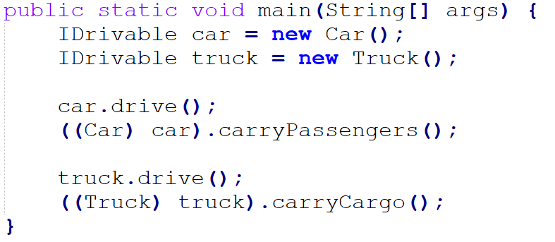
- Plugin System (Open/Closed Principle)
Description:
- Develop a plugin system for an application that allows adding new features through plugins.
Requirements:
- Define an interface IPlugin with a method execute().
- The application should load and execute plugins without modification.
- New plugins (SavePlugin, PrintPlugin,…) can be added by implementing the IPlugin interface.
Objectives:
- Apply the Open/Closed Principle to enable extensibility without changing existing code.
- Online Food Delivery System
- Background
With the rise of online food ordering services, there is a growing need for an efficient, flexible, and scalable Online Food Delivery System that allows customers to browse menus, place orders, and receive deliveries while supporting multiple payment and delivery methods. The system should ensure modularity, scalability, and adherence to SOLID principles to accommodate future business expansions.
- Problem Statement
The goal is to design and implement a system where customers can place orders at restaurants, make payments, and receive deliveries through different methods. The system should support various payment methods (e.g., Credit Card, PayPal, Cash on Delivery) and delivery methods (e.g., Motorbike, Drone, Rocket Delivery) while allowing restaurant owners to manage their menu offerings.
- Business Rules & Constraints
- Orders should be placed only if the items are available on the restaurant’s menu.
- Customers should be able to choose a payment method dynamically.
- The system must be open to new discounts, payment and delivery methods without modifying existing classes.
- The Order Service logic should be independent of payment and delivery implementation.

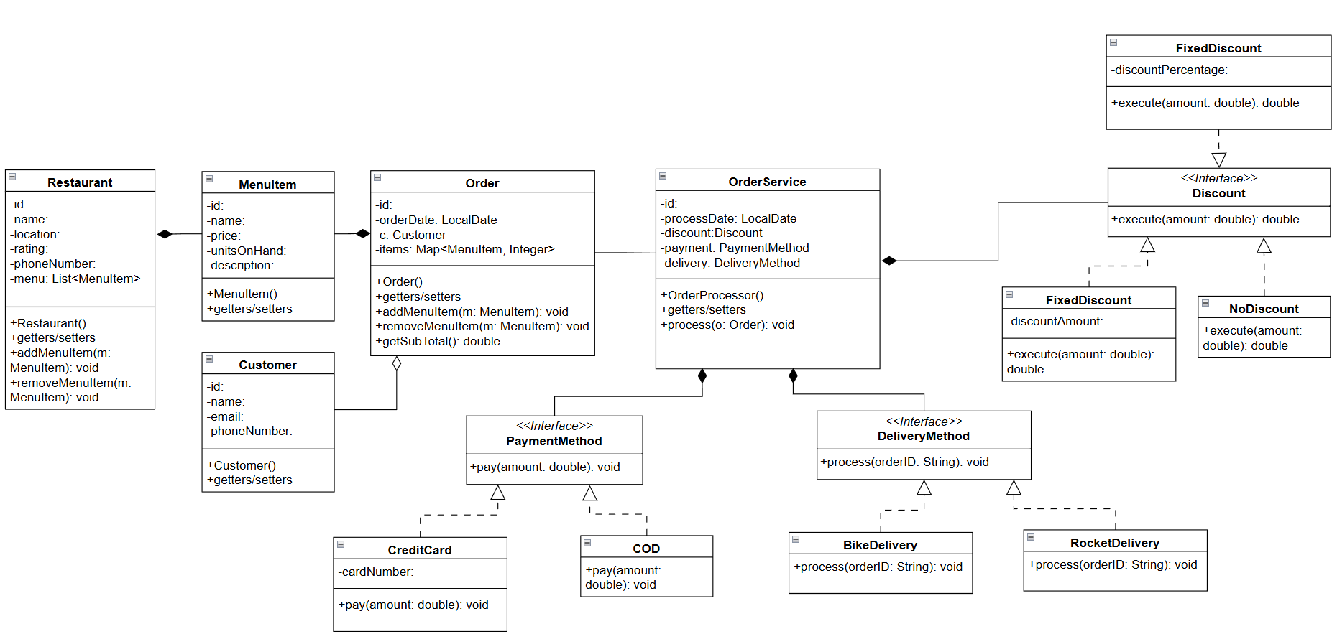
PercentageDiscount
Students are required to implement the system with the aid of the designed UML. The implementation must fulfill the business rules and constraints mentioned. Students are encouraged to propose any improvements.
Submit: Must include:
- a pdf file containing your information (student id, name), and images of the class diagrams, codes, answers
- and all source code files (if any)
in a zipped (.zip or *.rar) file to Moodle

